**CHAPTER 1**

1. **INTRODUCTION**

A home automation system using the Internet of Things (IoT) is a system that uses the internet to connect devices to each other and control a home's functions. This system can help make a home more comfortable, secure, and energy efficient.

Control and monitor: Users can control and monitor their home remotely using apps or virtual assistants like Siri, Google, or Alexa. IoT-enabled devices can learn and adapt to a user's habits and lifestyle. For example, a home automation system can turn off lights when a room is empty or adjust the temperature when no one is home. Schedule tasksUsers can schedule automated tasks for their home devices. Create cascading actions. Users can create cascading actions using IFTTT (If This Then That) triggers. For example, a user can set a trigger to turn on the air conditioning and roll down the blinds when the day temperature is above 25 degrees. Improve air quality: A home automation system can monitor air quality and open or close windows to ensure fresh air. Technically, any home with an internet connection and IoT devices can be considered a smart home.

Home automation is transforming the way we live, offering unparalleled convenience, efficiency, and security. By integrating smart devices and systems into our homes, we can control everything from lighting and temperature to security and entertainment with just a few taps on our smartphones or a simple voice command. Home automation is not just about making our lives easier; it’s about creating a more connected, responsive, and sustainable living environment.

Home automation devices does not only provide more comfort but also allows centralized control of heating, ventilation, air-condition, and lighting. Hence, they contribute to an overall cost reduction and also useful in energy saving which is certainly the main problem today.

As these technologies continue to evolve, they promise to revolutionize our daily routines, enhance our comfort, and provide us with greater peace of mind. In this article, we’ll explore the various home automation tools available, their benefits, and how they are reshaping modern living.

Home automation refers to the use smart technology to control and automate household appliances and systems, enhancing convenience, comfort, and energy efficiency. This technology allows homeowners to remotely monitor and manage devices such as lights, thermostats, security cameras, and even kitchen appliances through their smartphones or voice commands.

From setting up automated schedules to responding to environmental changes, home automation systems offer a seamless integration of technology into everyday living.

* 1. **NEED :**

Home automation systems can make your life more convenient and comfortable, and can also help you save money and energy:

1. Convenience:

You can control your home from a mobile device or tablet, and you can use voice commands to perform tasks.

1. Energy savings:

You can reduce energy waste by adjusting your thermostat, lighting, and shades based on the time of day or occupancy.

1. Safety and security:

You can monitor your home remotely with security cameras, doorbell cameras, and motion sensors. You can also set alerts for water leaks and break-in attempts.

1. Comfort:

You can control your air conditioning, blinds, and awnings, and you can set light schedules. You can also use smart devices to enhance your health and comfort, such as air purifiers and smart beds.

1. Entertainment:

You can integrate your audio, video, and streaming services, and you can create custom routines and scenes.

1. Accessibility:

Smart home devices can improve accessibility for people with disabilities or limited mobility.

1. Ecological footprint:

You can reduce your ecological footprint by optimizing your sprinkler system to consume less water.

However, the main disadvantage of a smart home is the cost. You need to consider the cost of the devices themselves, as well as the cost of internet bandwidth and smartphone storage.

* 1. **OBJECTIVES :**

1. Energy savings and efficiency: A home automation system makes it possible to design hourly programs to ration electrical loads of devices, disconnect plugs that aren't in use, etc. Furthermore, the system creates electricity consumption reports to optimize it.

2. Simplicity and commodity: Process automation facilitates the tenants' daily routines. For example, the air conditioning, raising and lowering of awnings and blinds, and watering system can be programmed, so users don't have to worry about these tasks.

3. Voice control: Tasks can be asked to be executed using the commands intended for this purpose or via a voice assistant. This makes it possible to send commands to any connected device, saying for example "turn off the lights in the living room" or "make a coffee."

4. Prevention and reduction of damages: Home automation technology warns of any type of leak, whether it be gas or water, thus preventing domestic accidents. Furthermore, as it is part of the same network, it's possible to find out the status of home appliances to perform maintenance tasks and extend their useful life.

5. Increased Property Value: Enhance the value of your property with modern home automation features.

6. Remote Monitoring: Access and control your home from anywhere, using smartphones or tablets.

7. Improved Safety for Vulnerable Individuals: Provide an additional layer of safety and security for elderly, disabled, or young family members.

8. Enhanced Entertainment: Create a seamless entertainment experience with automated audio-visual systems.

9. Reduced Maintenance: Automate routine maintenance tasks, reducing the need for manual intervention.

**1.3 PROPOSED WORK:**

#### 1. ****Project Overview****

Home automation, also known as smart home technology, refers to the use of automated systems to control and monitor various aspects of a home, including lighting, temperature, security, entertainment, and more. Home automation has come a long way, and its future scope is promising. As technology continues to evolve, we can expect to see even more innovative applications of home automation.

2. **Key Objectives**

* To automate routine tasks, making life easier and more comfortable.
* To optimize energy consumption, reducing waste and saving costs.
* To enhance home safety with automated security systems, surveillance, and alerts.
* To create a personalized and comfortable living environment with automated temperature, lighting, and entertainment systems.

#### 3. ****Scope****

The scope of this project includes:

* Home automation will become more mainstream, with more homeowners investing in smart home systems.
* Voice assistants like Alexa, Google Assistant, and Siri will continue to improve, making voice control the primary interface for smart homes.
* Voice assistants like Alexa, Google Assistant, and Siri will continue to improve, making voice control the primary interface for smart homes.
* A user interface (optional) for parents to customize settings (e.g., music playlist, volume, sensitivity to crying).
* Smart home systems will integrate with wearable devices, allowing for seamless control and monitoring.

#### 4. ****System Design****

##### 4.1. **Hardware Components**

* **Arduino Nano:** Arduino Nano is a small, complete, flexible and breadboard-friendly Microcontroller board, based on ATmega328p.
* **Bluetooth module**: It is used for wireless communication to replace the wired connection
* **Relay:** 5v relay is an automatic switch that is commonly used in an automatic control circuit and to control a high-current using a low-current signal.
* **Power Supply**: A reliable power source to ensure continuous operation.

##### 4.2. **Software Components**

* **C and C++ language: in this system we used basic C and C++ program for better command.**
* **Arduino Nano:** It is programmed using Arduino IDE, in Arduino we are inserted c programming code.
* **Arduino Bluetooth :** A simple app or control panel to control the Bluetooth module HC-05 module and give the command to the Arduino in binary language.

##### 4.3. **Flow of Operation**

1. **Bluetooth Module** : It gives the command from the user and send to the Arduino
2. **Device control** : The Arduino is forward the command to the devices which is getting from the user(ON/OFF).

**CHAPTER 2**

**2. THEORETICAL BACKGROUND**

**2.1 Literature review :**

**1. Bluetooth based home automation system using cell phones:**

In Bluetooth based home automation system the home appliances are connected to the Arduino BT board at input output ports using relay. The program of Arduino BT board is based on high level interactive C language of microcontrollers; the connection is made via Bluetooth. The password protection is provided so only authorized user is allowed to access the appliances. The Bluetooth connection is established between Arduino BT board and phone for wireless communication. In this system the python script is used and it can install on any of the Symbian OS environment, it is portable. One circuit is designed and implemented for receiving the feedback from the phone, which indicate the status of the device.

**2. Zigbee based home automation system using cell phones:**

To monitor and control the home appliances the system is designed and implemented using Zigbee. The device performance is record and store by network coordinators. For this the Wi-Fi network is used, which uses the four switch port standard wireless ADSL modern router. The network SSID and security Wi-Fi parameter are preconfigured. The message for security purpose first process by the virtual home algorithm and when it is declared safe it is re-encrypted and forward to the real network device of the home. Over Zigbee network, Zigbee controller sent messages to the end. The safety and security of all messages that are received by the virtual home algorithm. To reduce the expense of the system and the intrusiveness of respective installation of the system Zigbee communication is helpful.

**3.GSM based home automation system using cell phones:**

Because of the mobile phone and GSM technology, the GSM based home automation is lure to research. The SMS based home automation, GPRS based home automation and dual tone multi frequency (DTMF) based home automation, these options we considered mainly for communication in GSM. In figure shows the logical diagram the work of A. Alheraish, it shows how the home sensors and devices interact with the home network and communicates through GSM and SIM (subscriber identity module). The system use transducer which convert machine function into electrical signals which goes into microcontroller. The sensors of system convert the physical qualities like sound, temperature and humidity into some other quantity like voltage. The microcontroller analysis all signal and convert them into command to understand by GSM module. Select appropriate communication method among SMS, GPRS and DTFC based on the command which received GSM module.

**4.Wi-Fi based home automation system using cell phones:**

Wi-Fi based home automation system mainly consist three modules, the server, the hardware interface module, and the software package. The figure shows the system model layout. Wi-Fi technology is used by server, and hardware Interface module to communicate with each other. The same technology uses to login to the server web based application. The server is connected to the internet, so remote users can access server web based application through the internet using compatible web browser. Software of the latest home automation system is split to server application software, and Microcontroller (Arduino) firmware. The Arduino software, built using C language, using IDE comes with the microcontroller itself. Arduino software is culpable for gathering events from connected sensors, then applies action to actuators and preprogramed in the server. Another job is to report the and record the history in the server DB. The server application software package for the proposed home automation system, is a web based application built using asp.net. The server application software can be accessed from internal network or from internet if the server has real IP on the internet using any internet navigator supports asp.net technology. Server application software is culpable of, maintain the whole home automation system, setup, configuration. Server use database to keep log of home automation system components, we choose to use XML files to save system log.

#### 5. Home automation using RF module:

#### The important goal of Home Automation System is to build a home automation system using a RF controlled remote. Now technology is accelerating so homes are also getting smarter. Modern homes are deliberately relocating from current l switches to centralized control system, containing RF controlled switches. Today traditional wall switches situated in various parts of the home makes it laborious t for the end user to go near them to control and operate. Even further it turns into more problematic for the old persons or physically handicapped people to do so. Home Automation using remote implements an easier solution with RF technology. In order to accomplish this, a RF remote is combined to the microcontroller on transmitter side that sends ON/OFF signals to the receiver where devices are connected. By operating the stated remote switch on the transmitter, the loads can be turned ON/OFF globally using wireless technology stimuli.

**6. Home automation using Android ADK:**

The devices of home are associate to the ADK and the Connection is established between the Android device and ADK. The devices of house are link to the input/output ports of the board (EMBEDDED SYSTEM) and their current situation will have passed to the ADK. The microcontroller board (Arduino ADK) is based on the ATmega2560. It has a USB host connection to associate with Android based phones, and that is based on the MAX3421e IC. The two important features of Android Open Accessory Protocol 2.0(AOAP) are as follows: It has audio output that is from the Android device to the component and it also support for the component serves as one or more Human Interface Devices (HID) to the Android device. This paper depends upon Android and Arduino platform in which both are FOSS (Free Open Source Software). Including motion sensors for safety systems will detect an unauthorized action and it will automatically notice the user through cell phone or the security system.

**7.Cloud Based home automation system:**

Home Automation using cloud based system focuses on design and implementation of home gateway to collect data about data from home appliances and then send to the cloud-based data server to get store on Hadoop Distributed File System, it is process using MapReduce and use to implement a monitoring tasks to Remote user Presently home Automation System is persistently developing its resilience by assimilating the current characteristics which gratify the rising interest of the people. This paper presents the design and development of home automation system that use the cloud computing as service. The current system consists of three important units: the first part is cloud server, handle and controls the data and information of client and users and the status of devices The hardware interface module is the second part which implement the relevant connection to the actuators and sensing devices which give the physical service. Last part is Home Server, which construct the hardware device and gives the user interface. This paper focus to build the web services using cloud which is need for security and storage and availability of the data. The current system is cost efficient, reliable and comfortable which also gives a secured home automation system for entire family. The system is made up of various client modules for various platforms.

1. Cloud server Cloud Server is a central server aims on implementing services to the other sub modules. Central server serves as the data respiratory system and brain It implements three connections to the three sub modules viz home system, web configuration tool and mobile. The server evaluates the data it takes from the house, send current status to the mobile device and vice versa. A database is managing by the server and it is status gets updated as per the changes done at home end.

2. Embedded Program for Hardware Circuit Microcontroller, and.

3. Internet Client for any desktop or mobile phones.

**CHAPTER 3**

**3. SYSTEM DESIGN**

**3.1 Block Diagram With Description :**

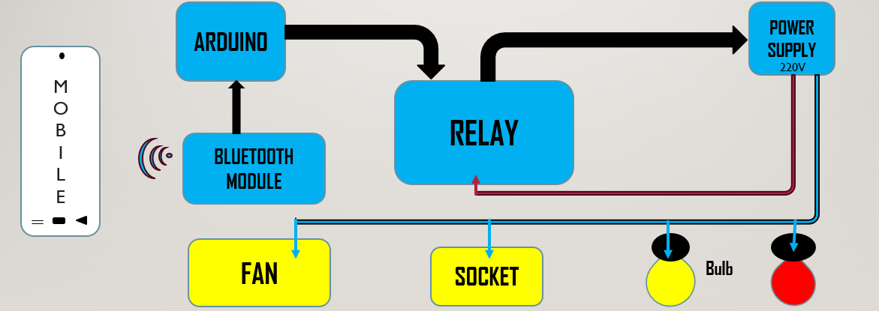

Fig 3.1 Block Diagram of Device control system

In this block diagram, we shows how to work the project in a simple method. In the project the main part is controller that is Arduino board. we will connect different peripherals to the Arduino. In this we connect Sound Sensor, Relay Module, etc. this project will helpful for baby sheeter. So here we use sound sensor to detect the voice of crying baby. Then the relay module is used to turn on or off the music system. In music player we added some music which will helpful to sleep the baby. Whenever the baby will cry the sound sensor will detect it and send signal to the Arduino. Then Arduino send signal to the relay. The relay will turn on so automatically music will be playing. And this process will continuously happen until baby isn’t stop crying.

1. **Arduino Board (e.g., Arduino nano)**
2. **Bluetooth Module (ex, HC-05)**
3. **Relay module**
4. **Mobile application (**ex, Arduino Bluetooth **)**
5. **LED and Bulb (for status indication)**

**Mobile application**

* **Function:** Gives the command from the user and provide to the Arduino..
* **Description The Mobile application which is Arduino Bluetooth is the basic main part of this project in that it is used for to communicate the data between user to the device**.

**Arduino nano**

### **Function:** Acts as the central processing unit of the system.

### **Description:** The microcontroller chip is responsible for analyzing the processed signals from the microphone, detecting patterns in the signal that correspond to a human. It passes the command to the devices which is getting from the user.

### 

### **Bluetooth Module**

* **Function: Forward the user command to the Arduino.**
* **Description:** Once the Bluetooth module get the command either it is 0 or 1 immediately it forward to the arduino.

### **Power Supply**

* **Function:** Provides the necessary power for all components.
* **Description:** A power supply (e.g., battery or AC adapter) provides the required voltage and current to the microphone, microcontroller, and audio player. This block is essential for the continuous operation of the system.

### **Output**

* **Function:** Outputs the lights are either on or off from the user command..
* **Description: At the final output we can control the all devices from the mobile application.**

**System Flow:**

1. **Signal Capture:** The Bluetooth module pick the command from the mobile application..
2. **Signal flow and command:** The sound signal is amplified and conditioned to focus on the sound frequencies of a baby’s cry.
3. **Cry Detection:** The microcontroller analyzes the conditioned signal using the cry detection algorithm to determine whether the sound is a baby’s cry.

**3.2 Hardware design with component details, circuit diagram with working description**

**1. ARDUINO NANO:**

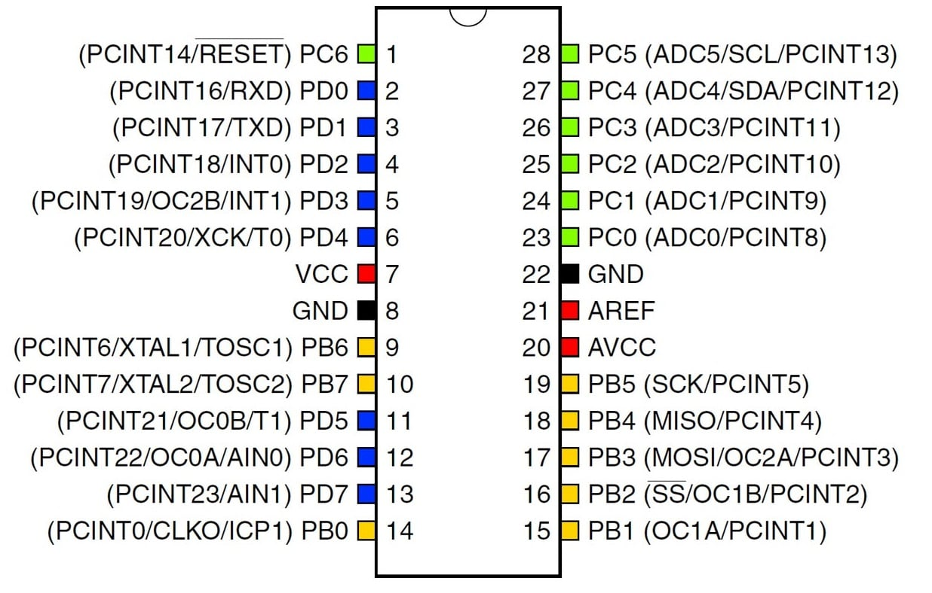

Fig 1. Arduino Nano

Arduino is a single board smaller scale microcontroller expected to make the use of intuitive protests or situations more available. The equipment comprise of an open source equipment board outlined around an 8-bit Atmel AVR microcontroller, or a 32-bit Atmel ARM. Current models highlight a USB interface, six simple inputs pins, and additionally 14 advanced I/O pins which permits a client to connect different augmentation sheets. Arduino Uno can sense the environment by using the sensor , sensor receive the signal from environment and send to the input part of Arduino, Arduino give the output from the output part as the programming burn in the microcontroller. Arduino accept a programming software called sketch. An Arduino can program infinite time. If a new program burn in the Arduino then previous program will automatically vanish. We can use multiple of sensor at a time and all the instruction sound sensor.

1. **BLUETOOTH SENSOR :**

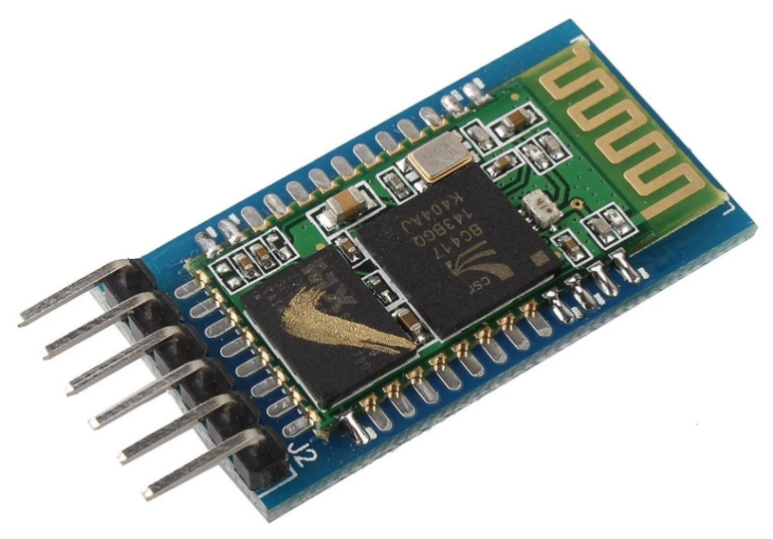

Fig 2. Sound Sensor

1. Device Discovery: Bluetooth devices search for nearby devices.

2. Pairing: Devices establish a secure connection.

3. Authentication: Devices verify each other's identity.

4. Encryption: Data transmission is encrypted for security.

5. Data Transmission: Devices transmit data to each other.

6. Data Reception: Devices receive data from each other.

Device A sends a inquiry message to discover nearby devices .Device B responds with its device name and address Device A sends a pairing request to Device B. Device B responds with a pairing confirmation. Device A and Device B establish a secure connection. Device A sends data to Device B. Device B receives data from Device A.

1. **LAMP :**

The LEDs are blow when Arduino pass the command as “HIGH” and for the off the command is “LOW”.



Fig 3: Lamp

1. **POWER SUPPLY CIRCUIT :**

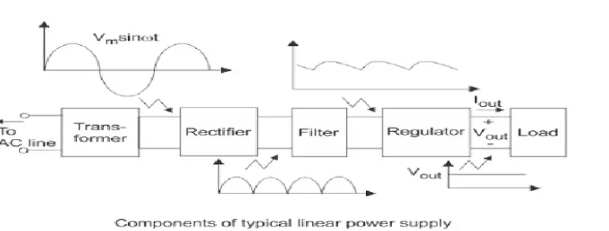

**Fig 4: Block diagram of power supply**

A power supply is a critical component in electrical and electronic systems, providing the necessary electrical power to drive circuits, devices, or systems. It converts electrical energy from one form to another, typically transforming an input voltage into a regulated output voltage that is suitable for the application.

• **AC Input (AC Mains)**:

* The input power supply is typically from the mains AC (alternating current) line, commonly 110V or 220V AC depending on the region. This block represents the raw input power.

• **Rectifier (Bridge Rectifier)**:

* The **rectifier** converts the AC input into pulsating DC (direct current) by using diodes (typically a bridge rectifier circuit) that allow current to flow in one direction only. This step is essential because most electronics use DC power, while the mains supply is AC.

• **Filter (Smoothing Capacitor)**:

* The output from the rectifier is pulsating DC, which still has ripples. A **filter**, usually a capacitor or a combination of inductors and capacitors, smoothens the ripple by reducing fluctuations in voltage, providing a more stable DC signal.

• **Voltage Converter**:

* Depending on the required output, the voltage converter either steps up (boosts) or steps down (buck) the voltage. If the input DC is too high or too low, a DC-DCconverter is used to adjust the voltage to the desired level. This could involve switching regulators or transformer-based designs.

• **Voltage Regulator**:

* The voltage regulator ensures a constant and stable output voltage, even if the input voltage or load conditions change. There are two main types of regulators:

The regulator maintains the output voltage at a precise level, either fixed (e.g., 5V, 12V) or adjustable based on the requirements of the load.

• **Output**:

* The regulated DC output is the final product of the power supply. It is now ready to power the electronic device or system that the power supply was designed for.

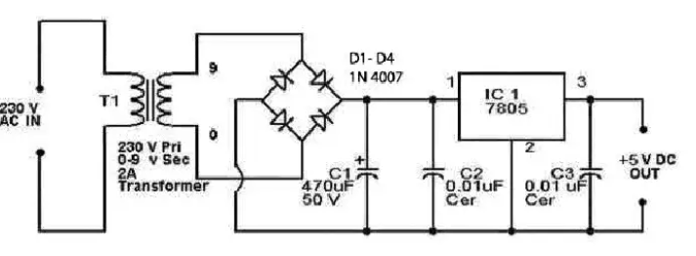

**Fig 5 : Circuit diagram of 5V power supply**

1. **LED :**

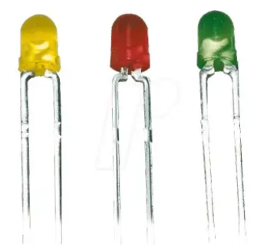

**Fig 6 : Led**

A **Light Emitting Diode (LED)** works based on a principle called **electroluminescence**. This is when a material emits light in response to an electrical current or a strong electric field. Here's a more detailed breakdown of how an LED functions:

### 1. **Basic Structure:**

An LED is a semiconductor device made up of a **p-n junction**. The p-type material has an excess of "holes" (positive charge carriers), while the n-type material has an excess of electrons (negative charge carriers). When the LED is connected to a power source, the current flows through the device.

### 2. **Electron-Hole Recombination:**

When the current flows through the LED, electrons from the n-type side move toward the p-type side, where they recombine with holes. As electrons move from a high-energy state to a lower-energy state (when they recombine with holes), they release energy in the form of **photons** (light).

### 3. **Energy Band Gap:**

The color (or wavelength) of the emitted light depends on the **energy band gap** of the semiconductor material. The energy difference between the electron’s excited state and its lower energy state determines the color of light. Different materials, like **gallium nitride (GaN)** for blue LEDs or **aluminum gallium arsenide (AlGaAs)** for red LEDs, are used to achieve different wavelengths of light.

1. **Relay Module**

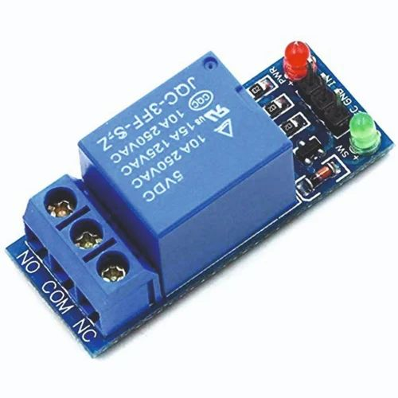

**Fig 6: Relay module**

**A relay module is an electromagnetic switch that allows a low-voltage signal to control a high-voltage circuit. In home automation, relay modules are used to control devices such as lights, fans, and appliances.**

1. **Trigger Signal:**

A trigger signal is sent from a microcontroller or other control device to the relay module.

1. **Relay Coil Activation:**

The trigger signal activates the relay coil, which switches the contacts on or off.

1. **Circuit Control:**

The contacts connect or disconnect the load circuit, controlling the device (e.g., turning lights on or off).

1. **Feedback Loop:**

Some relay modules may have a feedback loop that sends a signal back to the microcontroller or control device, confirming the status of the device.

1. **ESP32 WROOM :**

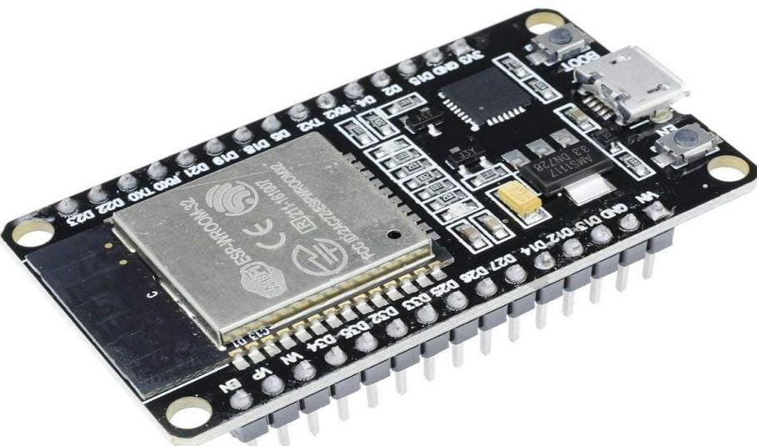

**Fig 7 : Mositure sensor**

The ESP32-WROOM-32 is a Wi-Fi, Bluetooth, and Bluetooth LE module with a variety of features, including:

1. ****CPU**:**Dual-core Xtensa LX7 CPU with a clock frequency adjustable from 80 MHz to 240 MHz
2. ****Co-processor**:**Low-power RISC-V (RV32IMC) coprocessor clocked at 17.5 MHz
3. ****Memory**:**512 KiB SRAM, 384 KiB ROM, and 16 KiB RTC SRAM
4. ****Peripherals**:**Capacitive touch sensors, SD card interface, Ethernet, high-speed SPI, UART, I2S, and I2C
5. ****Wireless**:**Wi-Fi 2.4 GHz (IEEE 802.11 b/g/n), Bluetooth 5 (LE)
6. ****Power**:**Sleep current of less than 5 µA, operating voltage of 2.7 V to 3.6 V, and operating temperature range of –40°C to +85°C
7. ****Certifications**:**FCC/CE-RED/IC/TELEC/KCC/SRRC/NCC,Wi-Fi Alliance, BQB, REACH/RoHS
8. ****Module interfaces****: SD card, UART, SPI, SDIO, I2C, LED PWM, Motor, PWM, I2S, IR, pulse counter, GPIO, capacitive touch sensor, ADC, DAC
9. ****On-chip sensor**:**Hall sensor
10. ****Integrated crystal**:**40 MHz crystal

The ESP32-WROOM-32 is a generic module that can be used for a variety of applications, including low-power sensor networks, voice encoding, music streaming, and MP3 decoding.

**3.4 Bill of material :**

|  |  |  |  |
| --- | --- | --- | --- |
| **Component** | **cost** | **Component** | **Cost** |
| **Arduino** | **210** | **LED** | **30** |
| **Relay** | **180** | **Bulb** | **200** |
| **Bluetooth module** | **180** | **Copper Clad** | **100** |
| **capicator** | **10** | **Connecting Wire** | **100** |
| **resistor** | **20** | **Total Cost =** | **1030** |

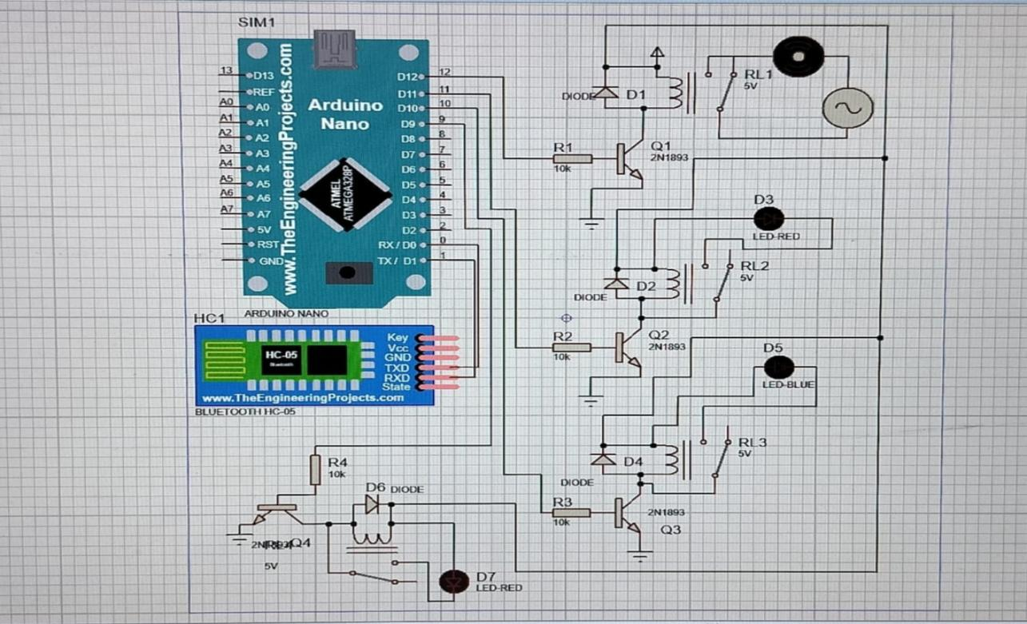**3.5 Software Design with simulation**

Fig 9 : circuit simulation

1 .Bluetooth Detection:

* The Bluetooth continuously monitors the environment for signals. When the signals are received then, it get an electrical signal through received command..
* The Bluetooth module received the command and send to the arduino for further processing.

2. Arduino Nano:

* The Arduino gets the command from bluetooth module and make implementation. the commands are 0 and 1, If command is 1 then it is true, 0 for false means that ON or OFF.
* Basically in arduino there is a program of C and Cpp which helps for the better result.

1. Output:

* When the user send the ON command then the arduino read this command and send it to the devices, in this all process relay gets triggered for current control and provide the electricity as needed.

1. Repeat Monitoring:

* The system continuously monitors the users command, ready to detect further cries and re-trigger the relays and arduino if needed to the user. This can be done on a continuous loop or with a Off command period (e.g., If the user wants to ON any device or OFF the device).

**3.6 Flow chart :**

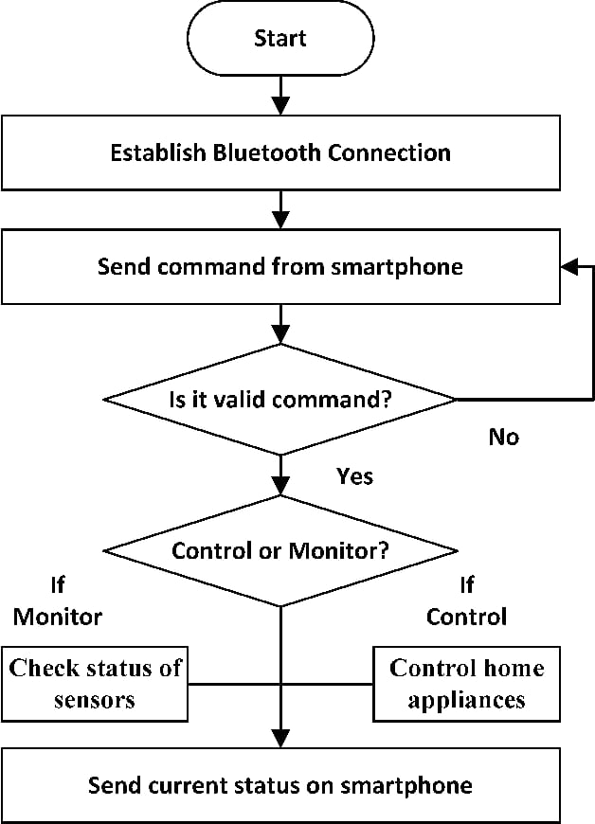

**Fig 10: Flow Chart**

**3.7 Complete flow of Program :**

1 .Bluetooth Detection:

* The Bluetooth continuously monitors the environment for signals. When the signals are received then, it get an electrical signal through received command..
* The Bluetooth module received the command and send to the arduino for further processing.

2. Arduino Nano:

* The Arduino gets the command from bluetooth module and make implementation. the commands are 0 and 1, If command is 1 then it is true, 0 for false means that ON or OFF.
* Basically in arduino there is a program of C and Cpp which helps for the better result.

1. Output:

* When the user send the ON command then the arduino read this command and send it to the devices, in this all process relay gets triggered for current control and provide the electricity as needed.

1. Repeat Monitoring:

* The system continuously monitors the users command, ready to detect further cries and re-trigger the relays and arduino if needed to the user. This can be done on a continuous loop or with a Off command period (e.g., If the user wants to ON any device or OFF the device).

**3.8 PCB Layout with PCB design steps:**

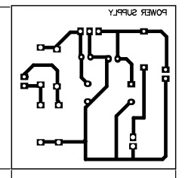 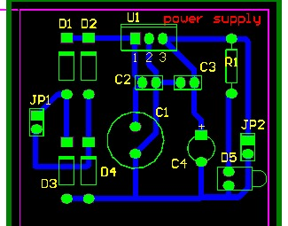

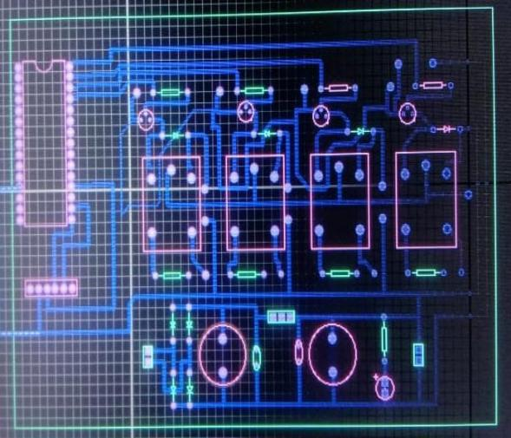 Fig : Power supply PCB layout

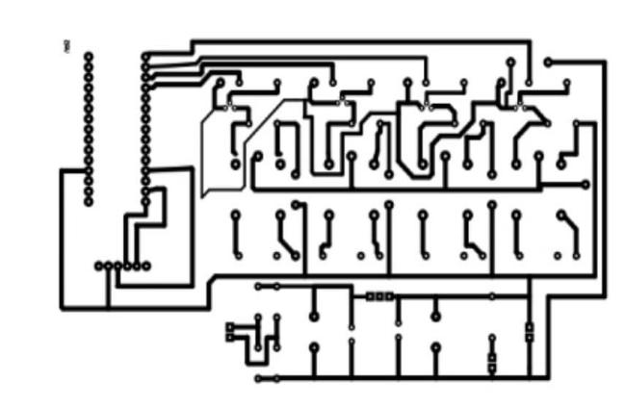

Fig : Full PCB layout

**CHAPTER 4**

**4.1 Result:**

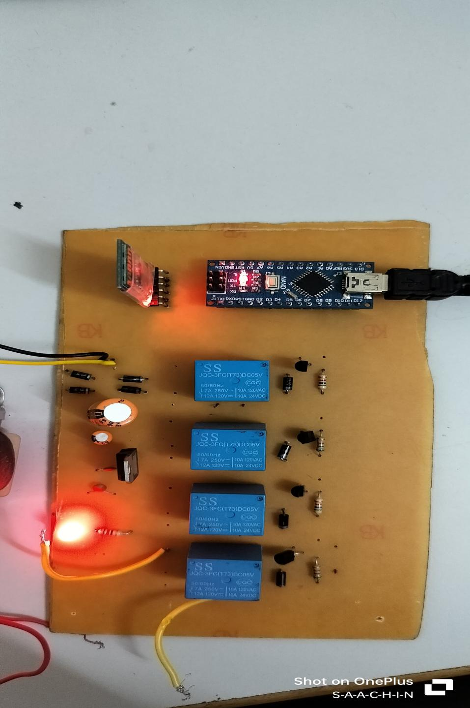

**4:1 Experimental setup (Collared photos, readings/Output )**

**4.2 Result:**

Our project Automating lighting, air conditioning, security, and communication can significantly reduce energy consumption and lower utility bills. Depending on the level of automation, bills can be reduced by 5–22%. Basically this IoT Based Device control is used for home appliances like light, bulb, fan , tube. In this project the bluetooth module is connected to the bluetooth arduino which is an application downloaded is mobile. After the succesfully connection the user send the command to the bluetooth module, and once it received further process is happens which is device control.

**CHAPTER 5**

**5.1 Conclusion :**

Home automation systems can improve your quality of life, security, and energy efficiency. Here are some conclusions about home automation systems.Home automation systems can adjust settings based on the time of day or occupancy, which can reduce power consumption.Home automation systems can be controlled remotely, even when you're away from home

**5.2 Future scope of the project :**

The proposed system now consuming to much power because the system is continuously turn on so in future, by doing some changes we make a power sufficient system. We will able to sleep our system until baby is not crying and whenever baby is start crying our system will detect and start music player so it will consume less power. Also we can add some sensors to detect the cushion is dry or wet so it will helpful to alert the parents through the bluetooth module.

**5.3 APPLICATIONS**

Home automation can be used for many things, including

### Energy management

* **Home automation can help reduce energy consumption by turning off lights when no one is in a room, or adjusting the temperature of the air conditioning system.**
* **Security**
* **Smart security systems can monitor your home in real time and send alerts to your phone if they detect suspicious activity. Smart locks can also provide an extra layer of protection.**

1. **Security**

* **Smart security systems can monitor your home in real time and send alerts to your phone if they detect suspicious activity. Smart locks can also provide an extra layer of protection.**

### 3 . **Comfort**

* Home automation can learn your preferences and adjust lighting and music to create a comfortable living space.
* Pet and baby care
* Home automation can track the movements of pets and babies, and control pet access rights. .

### 4. **Air Quality Control**

* Home automation can monitor air quality and pollution levels.
* Smart kitchen

### 5. Voice Control

* Voice control devices like Amazon Alexa or Google Nest can be used to control home appliances or systems.

### 6. **Smart blinds and shades**

* Smart blinds and shades can be operated remotely and adjusted automatically to manage natural light and privacy.

7.. Smart kitchen

* Home automation can help with refrigerator inventory, premade cooking programs, and cooking surveillance.

**CHAPTER 6**

1. **APPENDIX**

|  |  |  |  |  |  |
| --- | --- | --- | --- | --- | --- |
| Sr.No | Component | Specification | Unit Prize | Quantity | Cost |
| 1 | Arduino | i/o pins 13,7 | 210 | 1 | 210 |
| 2 | Dc power supply | max 105 W range 0-30VDC/0-3A | 150 | 1 | 150 |
| 3 | Bluetooth Module | 5 pins,rx, tx ,vcc,grd | 180 | 1 | 180 |
| 4 | capacitor | 0.02uf | 2 | 4 | 8 |
| 5 | resistor | 10k, 100k | 3 | 6 | 18 |
| 6 | diode | npn diode | 8 | 8 | 64 |
| 7 | LED | red led | 10 | 2 | 20 |
| 8 | Connector | m to m, m to f | 4 | 4 | 16 |
| 9 | Relay | 5 pins, 5V DC | 40 | 4 | 160 |
| 10 | Copper clad | copper plate | 50 | 1 | 50 |
|  |  |  |  | Total  Cost= | 876 |

* 1. **Programs :**

char val;

void setup() {

pinMode(13,OUTPUT);

Serial.begin(9600);

digitalWrite(13,HIGH);

}

void loop() {

if(Serial.available()){

val = Serial.read();

Serial.println(val);

}

if(val=='1'){

digitalWrite(13,LOW);

}

else if(val=='2'){

digitalWrite(13,HIGH);

}

delay(100);

}

**CHAPTER 7**

**6.1 REFERENCES**

1. https://www.repsol.com/en/energy-and-the-future/technology-and-innovation/what-is- home-automation/index.cshtml
2. .<https://www.researchgate.net/publication/338448686_Home_Automation_Systems>
3. <https://sist.sathyabama.ac.in/sist_naac/documents/1.3.4/1822-b.e-ece-batchno-65.pdf>
4. <https://naac.kct.ac.in/1/ssr/1_3_4/projects/17BMC026.pdf>